“Secrets of Spiritual Sadhana-2 - By Swami Mukundananda”
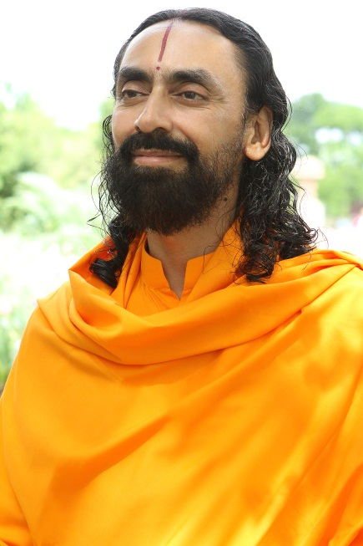
Swami Mukundananda is a world renowned spiritual teacher from India, and is the senior disciple of Jagadguru Shree Kripaluji Maharaj and founder of JK Yog. He has received his degrees in engineering from world renowned institutes in India, IIT and IIM. He has inspired people all over the world on the path of spirituality, holistic health, yoga, meditation, service to society and God realization. For details: www.jkyog.org

Secrets of Spiritual Sadhana-2 [Sadhana Karu Pyare]

Sadhana Karu Pyare is a unique philosophical compilation set in 54 lines and arranged in the form of couplets (dohas). In these lines, Shree Maharajji has summarized the entire philosophy of the knowledge of God and Guru (Philosophy of Divine Love).
Swamiji explained the complete set of 54 lines at the Puri Sadhana Shivir in 2008, which we will reproduce in this series.

This is the second line of "Sadhana Karu Pyare" series.
sādhanā te hī mile tohi, sādhya hari rati pyāre
"Only by doing spiritual practice one can receive the Divine Love of God."
We all have a sadhya. Sadhya means the thing which we want to achieve - our aim. What is our aim? Hari-Rati. Hari means God, Rati means Love. Our aim is to attain Divine Love of God. This Divine Love is our biggest treasure. All other treasures and possessions become insignificant in front of this treasure. Shri Maharajji says:
as ras mahaṁ mohiṁ sadguru borī
"My Gurudev has completely drenched me in the nectar of Divine love. So sweet is this nectar that compared to it, the combined fruits of 'dharm' (virtuous deeds), 'arth' (wealth), 'kaam' (material pleasure) and 'moksh' (liberation) are absolutely tasteless."
muktānām api siddānām nārāyaṇa parāyaṇaḥ sudurlabhaḥ praśhāntātmā koṭiṣhvapi mahāmune
Even the highly evolved yogis search for this Divine love of Radha Krishna. This Divine Love of Radha Krishna is very rare to attain. So, how will we get this Divine Love? Chaitanya Mahaprabhu explains us that we cannot attain this Divine Love by doing Sadhana or devotional practice.
nitya siddha kṛiṣhṇa prem sādhya kabhu nāy
śhravaṇādi shuddh chitt karay udāy
This Divine Love is an eternal entity that cannot be created by any meansnot even by Sadhana. And Shree Maharajji says Divine Love can be attained by doing Sadhana. Now here comes a contradiction. Our scriptures have such apparently contradictory philosophies and knowledge that without a true Saint or a Guru we cannot understand them. On one hand the scriptures say:-
nānugrahastava bina twayi bhaktiyogam
Without the Grace of God one cannot receive real devotion (Bhakti). On the other hand, the scriptures also say
nānugraham tava binātvaibhaktiyogaḥ
"Without doing devotion one will not receive the grace of God". Now these two precepts seem to be contradictory How will one receive devotion? Through Grace. How one will receive Grace? Through devotion. So what comes first? The chicken or the egg? Did the tree come first or the seed? If you say the seed came first, how could it come into existence without the tree? And if you say the tree came first, how did it come into being without the seed?
There is a similar contradiction here. One can ask, without the grace of God how can we do Bhakti? So first God should shower His grace and then we will start doing Bhakti. But how can God shower His grace if we do not do Bhakti? It seems like there is no way out of this puzzle. Does that means we should not do anything and sit quietly? Well, this circular logic is resolves quite easily.
Shree Maharajji says that there are two forms of Bhakti (Devotion) - one is that which we have to practice and the other is that which we will receive when our devotional practice is complete. The one which we have to practice and observe is called Sadhana Bhakti. The one which we will receive is called Siddha Bhakti (Prema Bhakti). This Siddha Bhakti will be attained by the grace of God. It is possessed by Rasik Saints who has been graced by Radha Krishna. So we need to do Sadhana Bhakti and then God gives Siddha Bhakti.
Ved Vyas says in Bhagwat -
bhaktyāsañjātayā bhaktyā vibhratyutpulakañtanum
"To receive Bhakti, one must do Bhakti". What does that mean? How can someone practice and receive the same thing in return? The verse actually means that we have to practice Sadhana Bhakti and once we have perfected it, we will receive Siddha Bhakti. However, even for the Sadhana Bhakti that we are supposed to do, we tell our Guru, "Guruji! Please grace me so that I can do Sadhana Bhakti". This is impossible. If without our efforts, merely by the Guru's grace everything could be done, then the world would not have remained. The Guru would have bestowed Siddha Bhakti on everyone, and released them from the bondage of maya.
God and Guru ask us to first realize and utilize the Grace that They have already showered on us. God has showered His grace in many ways - God has given us this human life. On top of that, we were born in India where we got a spiritual environment. We were bestowed with faith in God. Again by His Grace, we developed a desire to come to Satsang. And the biggest Grace was that we met a God-realized Saint and got attached to Him. He gave us the knowledge of God, showed us the right path of devotion and taught us how to practice it. After so many graces , if we do not utilize them, we have only ourselves to blame for it. In spite of knowing the importance of devotion we become lazy, careless and procrastinate in our spiritual practice. The more we realize and utilize the grace that God has showered on us, the more grace we will receive. If we do not utilize what we have already received, how can we expect more?
Shree Maharajji says, "I do not expect too much from you all. I know you cannot enter Golok in one day. But you do not do as much as you are capable of doing, and that is what makes me feel sad." The reason for this is our own laziness.
ālasya hi manuśhyāṇām śharīrastu mahān ripuḥ
The biggest disease of the human body is laziness. We know what we are supposed to do, but being lazy, we do not do it. Hence, in the preparatory stage, we have to work hard to overcome carelessness and do proper Sadhana. What is this sadhana, and how is it to be done? This is explained by Shree Maharajji in subsequent lines of this excellent kirtan

