“Secrets of Spiritual Sadhana-3 - By Swami Mukundananda”
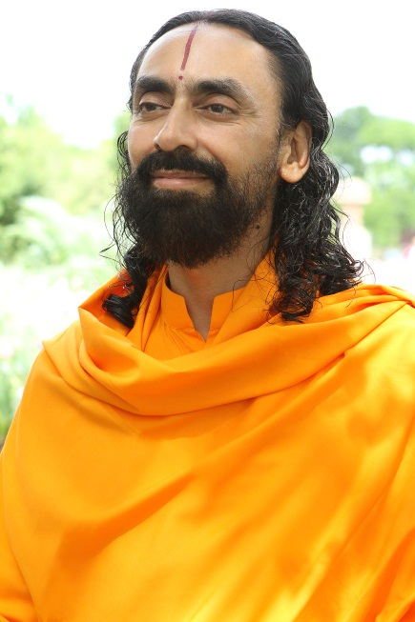
Swami Mukundananda is a world renowned spiritual teacher from India, and is the senior disciple of Jagadguru Shree Kripaluji Maharaj and founder of JK Yog. He has received his degrees in engineering from world renowned institutes in India, IIT and IIM. He has inspired people all over the world on the path of spirituality, holistic health, yoga, meditation, service to society and God realization. For details: www.jkyog.org

Secrets of Spiritual Sadhana-3 [Sadhana Karu Pyare]
Sadhana Karu Pyare is a unique philosophical compilation set in 54 lines and arranged in the form of couplets (dohas). In these lines, Shree Maharajji has summarized the entire philosophy of the knowledge of God and Guru (Philosophy of Divine Love). Swamiji explained the complete set of 54 lines at the Puri Sadhana Shivir in 2008, which we will reproduce in this series.
These are the next two lines of "Sadhana Karu Pyare" series.
pratham śhraddhā yukt ho jā śharaṇ guru pad pyāre
guru kī buddhi me.ṁ joṛ nij buddhi, hai śharaṇ yaha pyāre
In this verse, Shree Kripaluji Maharaj teaches us how to practice Sadhana (Devotion). He says, we should first faithfully surrender to a Guru (a God-realized Saint whom we have chosen to be our Spiritual Master). We should wholeheartedly follow His every instruction and teaching. This is the true beginning of Sadhana or spiritual practice. By surrendering ourselves to a Guru, we begin our spiritual journey.
In the material world, we gain knowledge by trusting the words of people with a higher intellect. Let us suppose that a person without any knowledge of law visits an advocate. The advocate teaches him how to tackle questions in a court to escape penalties. If the person does exactly as told by his advocate, he might win the case. We see that by having faith in the advocate's words, the person overcomes his challenges.
Similarly, when we are sick, we completely trust a doctor for our treatment without having any knowledge of medicine. We follow his instructions with full faith to get well. If we take medicine according to our wish, then it could be harmful to us. Even at school, we follow the words of people with a higher intellect (teachers), and complete our education.
We have to apply the same principle in the spiritual realm also. First, we have to search for a true Saint. Till we find a true Saint (God-realized Saint) we have to keep searching for Him. Once we find and accept such a Guru, we must stop searching and visiting other Saints. We have to surrender our mind to that Guru and do exactly as He instructs, without any questions or arguments. This is true or complete surrender - surrender of the mind.
Arjun committed the same mistake as above, with respect to the point of surrender of the mind. At the start of the great war (Mahabharat), Arjun said "O Shree Krishna! I do not know what I have to do. You are my Guru and my shelter." Shree Krishna said "If you consider me as your Guru, then I order you to go to war". Arjun replied "That is alright but..."
Here we see that Arjun applies his mind (intellect) against the wishes of his Guru. He is not following his Guru's instructions. Shree Krishna replies "If you use your mind then why do you consider me your Guru? Arjun says, "If I kill, it will be considered as a sin and the wives of soldiers will become widows. Their next generation will suffer." Shree Krishna replies, "If you know more than me, then why don't you become the Guru, and I will be your disciple?"
Accepting a saint as a Guru implies, "I do not know anything. You are my master (guide) and hence I am surrendering my mind (and intellect) to you."
So, in this way we have to surrender our mind to our Guru, and govern our intellect according to His teachings and instructions.
Shree Krishna said in Geeta-
ajñaśhchāśhraddhdānasya sañśhayātmā vinashyati |
nāyam lokosti na paro na sukham sañshayātmanaḥ |
"A sceptic or the one who doubts the authenticity of the spiritual path is bound to fall down". The one who has no faith in God or Guru is destined to fall down. That person will neither be happy in this world, nor can he aim to attain happiness in the spiritual realm. Even in this material world, we survive on the basis of faith, which is the pillar of our lives. For ex., we work all day in an office in the hope and faith that at the end of the month we will get paid. If we begin to doubt whether we will be paid or not, then we will not be able work.
Similarly, when we deposit money at the bank, the cash is presented at the counter to the cashier. The banker counts the money while you wait outside. Finally, he gives you a receipt/voucher. Now, if you begin to doubt the banker and say, "Why don't you give me receipt first, I will then give you the money"? The banker will surely be surprised and will advice you that it does not work that way. So, without faith there is no transaction.
Even in the spiritual realm, faith plays a very important role. It is only on the basis of faith that we can surrender to our Guru. We should have a firm faith that, whatever our Guru instructs is for our own benefit. We should have this unwavering belief that our Guru will never cheat or betray us. A Saint always wishes the best for any person, so whatever He advices or instructs is for the welfare of that person. When we gain complete faith in His words, then we will surrender to Him blind-folded and without any fear.
Ved Vyas said -
dhāvannimīlya vā netre, naskhalennapatediha
"Bhakti is such a Divine path that you can embrace it blind folded."
God Himself protects his devotee or Bhakt in this path. If we take one step towards God, He will take many more towards us. Be faithful and you will undoubtedly receive His Grace in the form of true devotional feelings. Hence, Faith is the foundation of surrender on which we can move ahead in the spiritual path.
The Bible says:
We walk by faith and not by sight.
This means we move towards God on the basis of faith and not what we perceive with our material senses. In the beginning, we can only associate with a Guru and cannot meet God directly. So, we have to first build that trust in a Guru.
There is a very good story related to faith. Once upon a time a Saint and his disciple were traveling. To beat the afternoon heat, they decided to rest under a tree. It so happened that the Guru woke up in between and to his surprise, saw a vicious snake about to sting his disciple. At that very moment, Guru decided to kill the snake. Startled, the snake said "Don't kill me. I cannot rest in peace till I drink his blood to avenge his actions from a past life." The Guru replied, "If you want his blood, I will give it you, do not bite him." The snake agreed to this deal.
So the Guru held a knife at his sleeping disciple's neck, to draw blood for the snake. Meanwhile, the disciple woke up and saw his Guru sitting on his chest and cutting his neck with a knife. The disciple was not at all worried. He was completely relaxed. He closed his eyes and went back to sleep. The Guru continued to cut one of the veins and gave the snake what it asked for.
When the disciple finally woke up, his Guru asked him "I held a knife at your neck, yet you did not doubt my intentions. Why?" The disciple answered "Guruji, I know that you are my well-wisher and you will always think of my benefit. That is why I was totally relaxed and slept peacefully."The Guru said "Very Good Son! Well done. You have made me proud today."
If anybody can develop such a strong faith in a Guru then God realization is not very far. But it is difficult for a disciple to have this kind of faith in the preliminary stages, even if the Guru is a God-realized Saint. This is because the disciple is under the influence of Maya (eternally existing, lifeless, cosmic power of God) and a Guru is beyond Maya.
That is why in the beginning, a disciple tries to judge the capabilities of a Guru and starts doubting or arguing with his Guru's instructions. "Why did Guruji order me to do this job? should I do this or not?" The disciple questions and argues in his mind, but the Guru also knows his disciple's thoughts. He knows that a child learns to walk step by step.
What is the meaning of true surrender? Shree Maharajji tells us to use our mind in accordance with the desire of our Guru (unite our mind with that of our Guru). That alone is the true surrender of the mind. If we say that "Guruji, I am your disciple and under your shelter", Guruji says "Ok then, do this task". If we reply, "No Guruji, I cannot do this", then this is not true surrender.
King Harishchandra demonstrated true surrender to his Guru, Sage Vishvamitra, who asked him to give away all his wealth. Harishchandra surrendered all his wealth without an argument. Vishvamitra again asked for ten thousand gold coins. Harishchandra was penniless, yet he never refused. All he said was "I want some time to carry out your instruction". He worked hard but could not collect the required money. He then sold himself and started working in a cemetery. In this way he paid the money and fulfilled the desire of his Guru.
After this incident, Harishchandra's son died of a snake bite. Harishchandra's wife came to the graveyard with her son's body and said "I want to cremate the body but I do not have the money for it. Harishchandra said "I cannot disobey my master. Instead of money you can give me a part of your clothes."
At that very moment God and Guru appeared in front of them. His Guru said "Stop! This is enough. You have exceeded your Guru's expectations and set the finest example of surrender to a Guru."
Therefore, Kripaluji Maharaj writes in 'Radha Govind Geet' -
guru ājñā pālan hī govind rādhe |
hariśhchandra ko golok dilā de ||
By faithfully obeying Guru's instructions, Harishchandra attained Golok.

So, surrender of the mind alone is true surrender.

